Question 1 - Experimenting with Layout  
By using the following specified layout managers, write Java applications that create two rows of buttons, for example, “Button 1”, “Button 2”, and “Button 3” are in the first row and “Button 4”, “Button 5”, and “Button 6” are in the second row.

* FlowLayoutManager
* BorderLayoutManager
* GridLayoutManager

[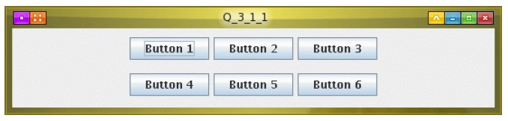](https://sites.google.com/a/iemcal.com/cs504d-oop/buttons.jpg?attredirects=0)

Question 2 - Event Handling  
Modify your code from Question #1 so that your application will print a message directly on the window indicating which button was clicked.  Please use your favourite layout manager.

[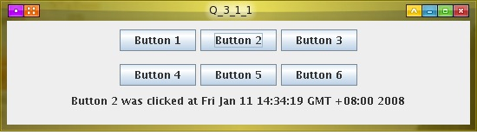](https://sites.google.com/a/iemcal.com/cs504d-oop/buttonsWithLabel.jpg?attredirects=0)

Question 3  
Modify your code from Question #2 so that you can scribble on the window by dragging the mouse.

[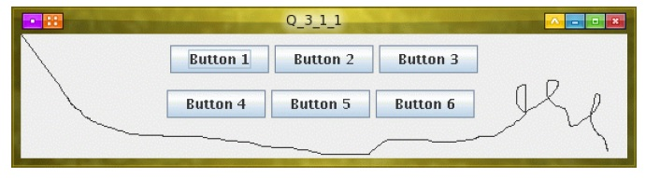](https://sites.google.com/a/iemcal.com/cs504d-oop/buttonsWithScribble.jpg?attredirects=0)